CARMAX RUNBOOK

Agent = windows 2019

Install nugget plugin

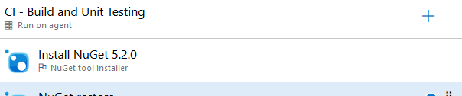

Install nugget restore plugin

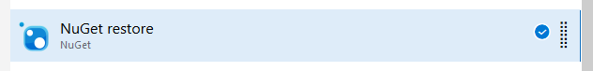

Nugget restore config

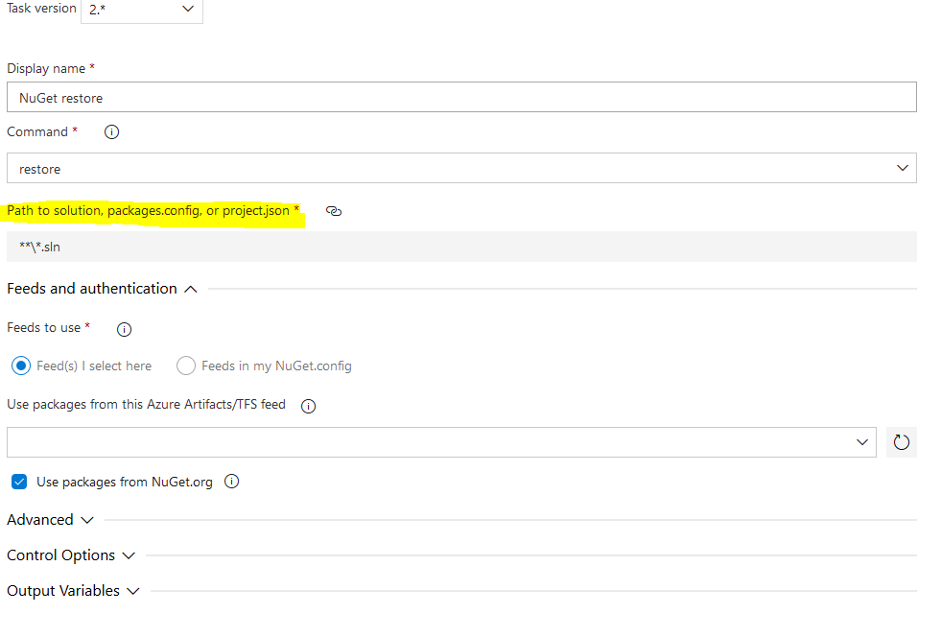

Begin sonar qube plugin

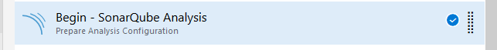

Sonar qube analysis start config

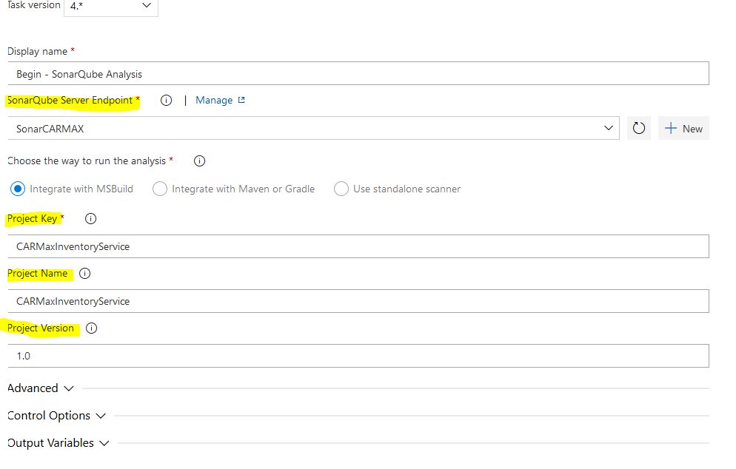

MS build plugin

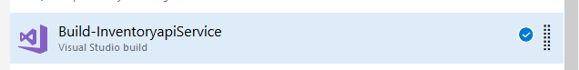

MS build config

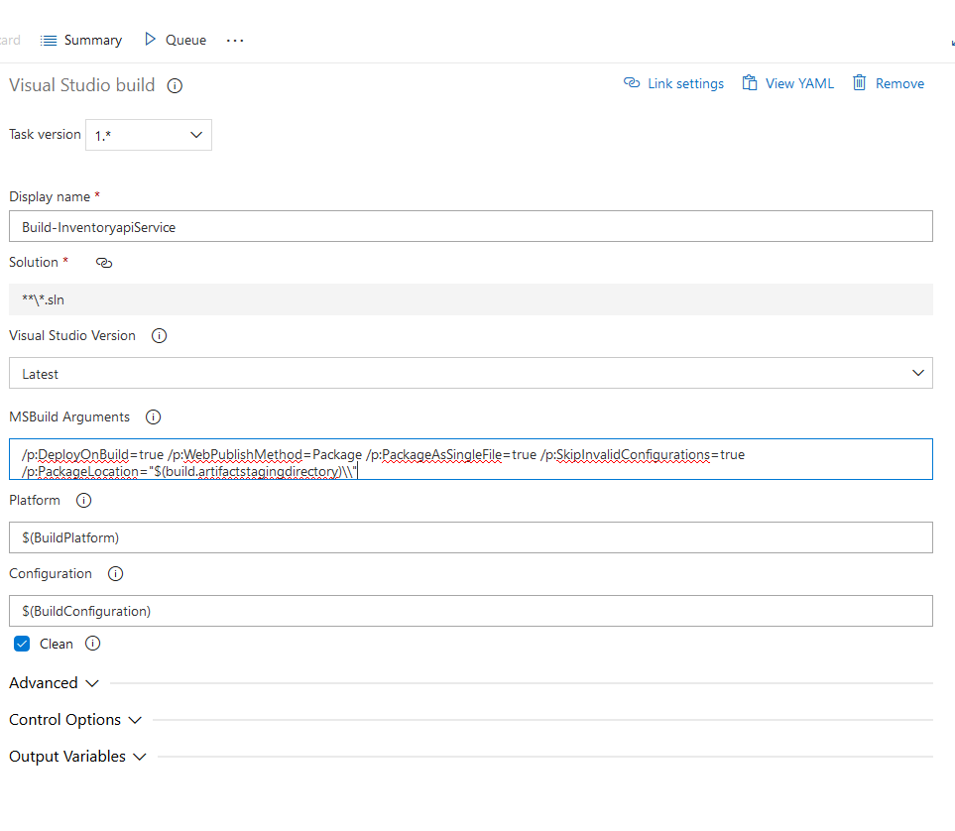

Dot net unit testing



Dot net unit test config

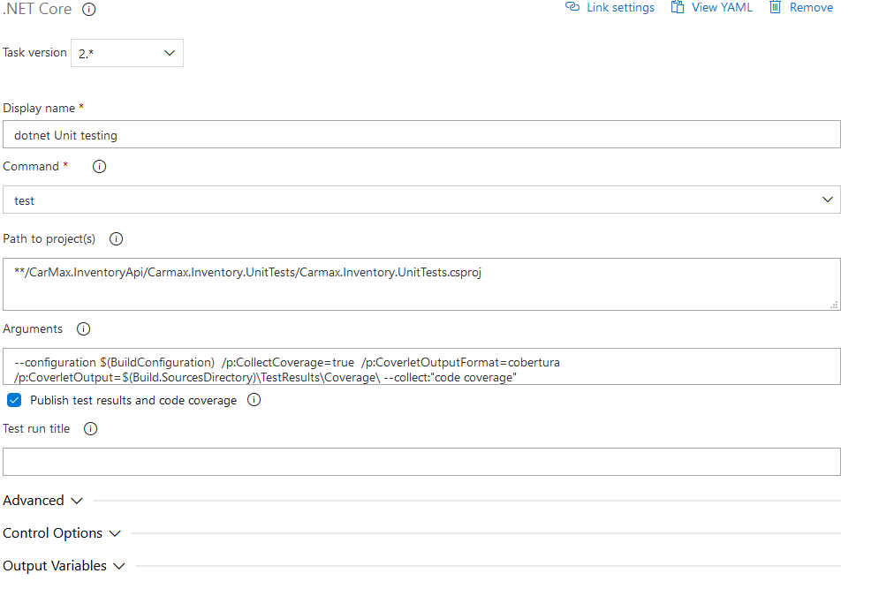

Sonar Qube end plugin

